PAWWSIE PRD
Project Name
Pawsie: a platform to connect pet owners and pet sitters
Description
Pawsie is more than a pet-sitting platform—it’s a trusted community where pet lovers and sitters connect with ease, care, and confidence.
This project resonates with my interests since I’m currently running a pet sitting business at my place in Mascot.
Market Context
There is wide demand for pet sitting services in Australia. MadPaws and PawShake are the biggest players in the current market.
Pawshake is a global pet-sitting platform founded in 2013, operating in over 20 countries across Europe, Asia, and Australia. With estimated annual revenue over $120 million and strong investor backing, it connects pet owners with trusted sitters through a tech-driven, community-first model
Mad Paws, launched in Sydney in 2015, is Australia’s leading pet care marketplace. With over 300,000 users, it went public and was acquired by global giant Rover in a A$62 million deal, expanding its reach through Rover’s international network while staying rooted in Aussie pet culture.
Market Opportunities
- Sitters could be better engaged with loyalty rewards to keep using the platform for longer time.
- Owners could get better discounts or deals if they keep using the platform.
- The user experience could be improved for Owners and Sitters.
- The platform could be used to offer extra services related with the pet business.
Target Customer
Pet Sitters & Owners
Features included in MVP
For this COMP9001’s MVP, Pawsie will be built as a mainly python web application where Owners and Sitters will be able to do the following tasks:
Owners Tasks:
- Create account
- Login
- Update owner profile
- Search sitters by service type, city
- Choose service and complete booking
- Read past bookings
- Can pay service (mock checkout)
- Can get a receipt (txt file)

Sitters Tasks:
- Create account
- Login
- Update sitter profile
- Update services and prices offered
- Can confirm/reject service
- Can read services accepted

Technical Requirements
The following diagram describes the tech stack used by Pawsie MVP, including database, back-end and front-end requeriments.
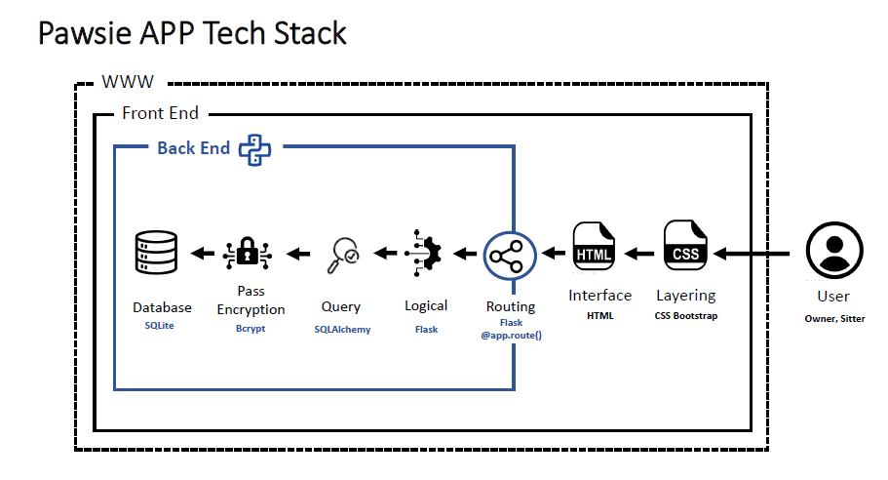

Database: Pawsie uses SQLite to store data and SQLAlchemy to query data according to functional definitions. The following table detail the database DDL schema.

General Database Definitions | Function Name
Create database schema SQL Alchemy | db = SQLAlchemy()
Create tables and Schema | def init_db()
Reseting database (Delete + Create) | def reset_db()

DDL for SQL Alchemy | Class
User Table | class User(db.Model)
Sitter Services Table | class SitterService(db.Model)
Bookings Details Table | class Booking(db.Model)
Payments Details Table | class Payment(db.Model)
CHECK Constraint in User Table | class Role(enum.Enum)
CHECK Constraint in SitterService Table | class ServiceType(enum.Enum)
CHECK Constraint in Bookings Table | class BookingStatus (enum.Enum)

Back-end: Pawsie uses Python and some extended libraries such as Flask, Bcrypt to create the logical layer and routing. The following table detail each function and its main purpose:
Owners Functional Definitions | Function Name
Create account | def register
Validate email exists | def register
Store user in session | def register , def login
Email Format Validation | def validate_email_format
Password Format Validation | def validate_pass_strength
Encrypting Password | def register
Login | def login
Desencrypting Password | def login
Match email/password in database | def login
Update owner profile | def owner_dashboard
Search sitters by service type, city | def search
Read bookings | def owner_bookings
Choose service and complete booking | def book_service
Can pay service (mock checkout) | def payment
Confirmation | def confirmation
Can get a receipt (txt file) | def download_receipt

Sitters Functional Definitions | Function Name
Create account | def register
Validate account exists | def register
Email Format Validation | def validate_email_format
Password Format Validation | def validate_pass_strength
Login | def login
Match email/password in database | def login
Update sitter profile | def sitter_dashboard
Update services and prices offered | def setup_sitter_services
Can confirm/reject service | def update_booking_status
Can read services accepted | def sitter_inbox

Front-end: Pawsie will have a web interface built with Flask Jinja2 templates and CSS Bootstrap. The following table detail each template/route used in this project.
Template/ Route | Description
/landing | Home page
/register | Register Form
/login | Login Form
/owner-dashboard | Dashboard for Owners
/owner-bookings | Record bookings for Owners
/sitter-dashboard | Dashboard for Sitters
/sitter-inbox | Incoming bookings for Sitters
/search | Search page
/book-service/… | Booking Flow
/payment/… | Checkout
/confirmation/… | Confirmation Page

Mock Up Data
The following data can be used to use the web application and test al the functional definitions.
User | Password | Role
fernando@gmail.com | Testing123 | Sitter
diana@gmail.com | Testing123 | Sitter
julian@gmail.com | Testing123 | Sitter
rachel@gmail.com | Testing123 | Sitter
ali@gmail.com | Testing123 | Owner

Scaling Phase (out of scope)
After COMP9001, Pawsie project may scale with the following features:
- Replace SQLite with PostgreSQL
- Wrap backend with React Native or Flutter to build APP
- Set up real payment method
- Search sitter by location inside a map
- Include rating and review system
- Improve UX / UI

